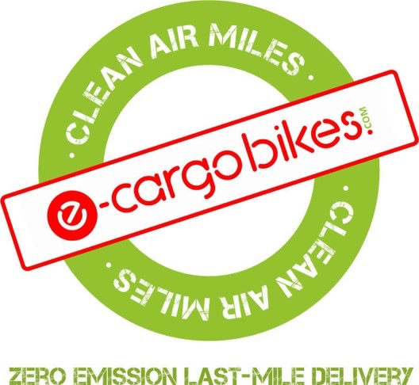
ECB Coronavirus Protocols for riders as of 17/03/20

Mindful of a duty of care to both our staff and our clients' customers' well being and with no detailed instruction on protocols received from our clients we have put the following procedures in place. Some processes have been in place for some weeks and some measures have been put in place from today following latest recommendations from government.

- Riders temperature is taken with an infrared thermometer at arrival to the Hub before each shift. Anyone with a temperature above 38.8 degrees will be sent home.

- In line with government advice all staff have been told that if they, or members of their household, develop the symptoms specified by NHS England advice they self-isolate for 7 days if they live alone, and 14 days if they live communally.

- Riders have been instructed to:

- Regularly wash personal equipment and uniform worn while delivering

- Wipe down the inside of coolbags, PDAs, hand grips, gear and brake levers, display panels, locks and box catches before and after shift with 70% alcohol wipes provided and dispose of the wipes in the waste bin.

- Wash hands with soap and hot water thoroughly and regularly and always before you head out on the bike.

- Each bike is now equipped with latex gloves and 70% alcohol wipes. All wipes and gloves are disposed of in the white bags provided in on board kits after use and when back at the hub these are put in the waste bin, not left in the bike box.

- CONTACTLESS DELIVERIES: From 17/03/20 riders have been told to proceed with contactless deliveries. This means that customers do not sign for deliveries. Riders sign (P.P and riders' signature) in front of customer and take a photograph of the goods with the customer or at the door and with door number so we can prove delivery if later challenged. Goods are not handed directly to the customer, but put on the ground. Until today, we had advised riders to take these measures only with customers identifying as self-isolating, but from today we are asking riders to follow this procedure for all deliveries.

- Riders have been told they can call the customer from outside the house and POLITELY ask if they are SELF-ISOLATING. They are instructed to use this wording - NOT if the house is 'virus free' - people may be self-isolating because they know they are more vulnerable - having chemotherapy for example.

- CHALLENGE 25: If customers are self-isolating and delivery includes challenge 25 items riders have been instructed to ask customers to show ID through a window. If this is not feasible (in a block of flats for example) they have been told to ask customers to open the door and show ID from a distance of 2 meters. In this instance riders have been asked to use their judgement in gauging the age of customer and cancel the order if in doubt. We would like more guidance from the Co-op on this. Do they have plans to request customers establish if they are self-isolating at the ordering stage? If so will Co-op be restricting the sale of Challenge 25 items to these customers as some other grocers are doing?

- We continue to monitor the situation and expect to implement further precautionary measures should they be required in line with measures being taken by other companies working in this sector.

- Various measures are in place at our Hubs in order to limit chances of contagion and all staff are being offered use of e-bikes to commute so that they can avoid using public transport.

